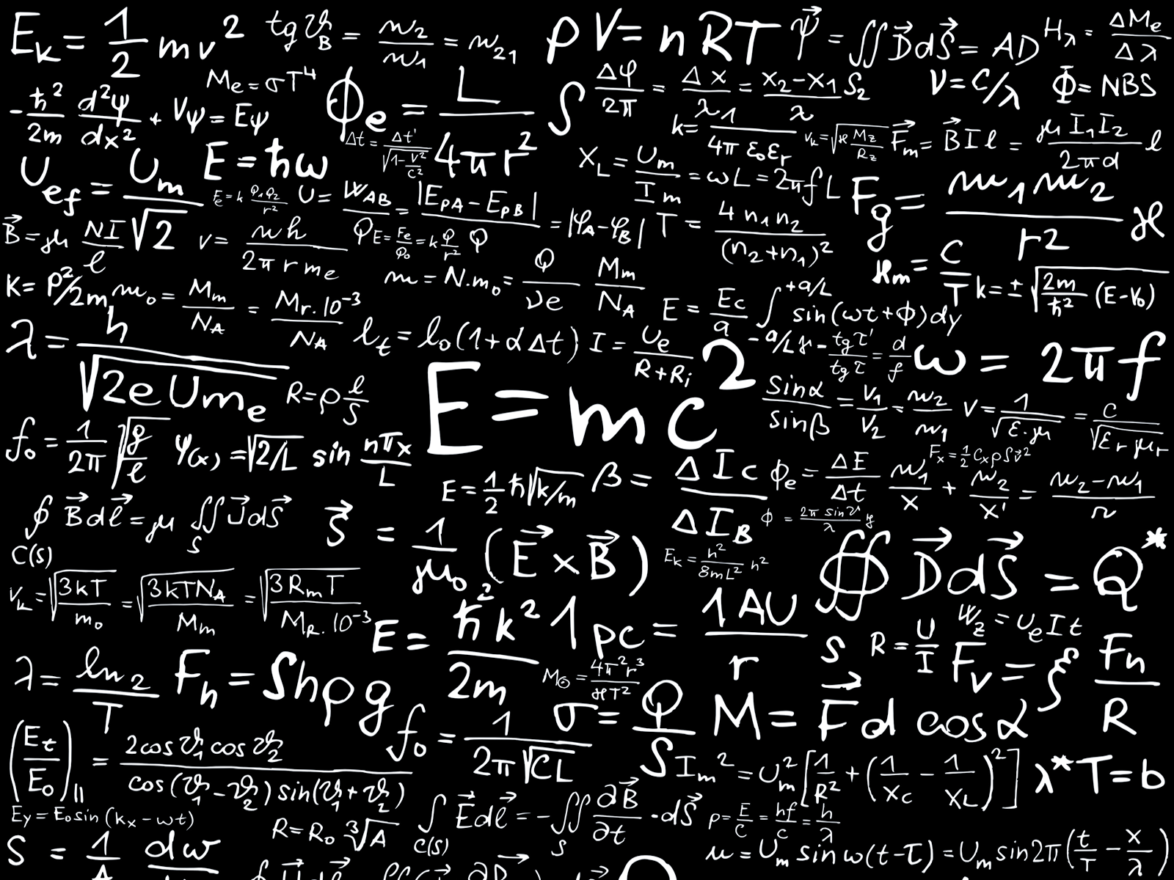

Exámen 2

Matemática Discreta

Andrés Montenegro

UTC



**SEGUNDO EXAMEN MATEMATICA DISCRETA CUATRIMESTRE II. 2020**

**LIC. MAURICIO MASIS SEAS**

**Problema 1**

1. gráficamente el dígrafo D = (Z+,R), donde R es la relación definida sobre el conjunto de los números naturales consistente en todos los pares de números de la forma (x, x + 2).

a. Trace una idea del dígrafo correspondiente al menos con 5 pares de ordenados que pertenecen a la relación.5pts

**Problema 2**

2. Para U = Z+, A = {2, 3, 4, 5, 6, 7}, B = {10, 11, 12, 13, 14}, escribir los elementos de la relación R A × B, donde

aRb si y solo si **a** divide (exactamente) a **b.**

1. Calcule  de la relación R 5pts

A x B = {{2,10},{2,11},{2,12},{2,13},{2,14},{3,10},{3,11},{3,12},{3,13},{3,14},{4,10},{4,11},{4,12},{4,13},{4,14},{5,10},{5,11},{5,12},{5,13},{5,14},{6,10},{6,11},{6,12},{5,13},{6,14},{7,10},{7,11},{7,12},{7,13},{7,14}}

B%A = 0

** =**

**{{2,10},{2,12},{2,14},{3,12},{4,12},{5,10},{6,10},{7,14}}**

b .De la matriz relación correspondiente de R 3pts

**10 11 12 13 14**

**2 1 0 1 0 1**

**3 0 0 1 0 0**

**4 0 0 1 0 0**

**5 1 0 0 0 0**

**6 1 0 0 0 0**

**7 0 0 0 0 1**

**Problema 3**

3 .A = {huevos, leche, maíz} y B = {vacas, cabras, gallinas}. Escribir la relación R de A a B definida por:

(a, b) e R a es producido por b.

Calcule  de la relación R. 4puntos.

** =**

**{{huevos,gallinas},{leche,vacas},{leche,cabras}}**

De la matriz relación correspondiente de R.3puntos.

**vacas cabras gallinas**

**huevos 0 0 1**

**leche 1 1 0**

**maíz 0 0 0**

**Problema 4**

4.Sea A = {1,2,3,4} y deﬁnimos la relación

aRb ⇐⇒ b es múltiplo de a, ∀a, b ∈ A

** =**

**{{1,1},{1,2},{1,3},{1,4},{2,2},{2,4},{3,3},{4,4}}**

a. Calcule la matriz de la relación R. 4 puntos.

**1 2 3 4**

**1 1 1 1 1**

**2 0 1 0 1**

**3 0 0 1 0**

**4 0 0 0 1**

b. Tracé el dígrafo correspondiente de R.3puntos.

C. Encuentre todas las trayectorias de lonquitud 2.USANDO PRODUCTO BOOLEANO DE MATRICES.. 4 puntos.

**Problema 5**

5. Dados los conjuntos:

A = {x ∈ N / 0 < x < 15}

B = {y ∈ Z / -5 < y < 25}

Se define la relación:

R = {(x,y) ∈ A x B / y = 1 + x2}

A = {1,2,3,4,5,6,7,8,9,10,11,12,13,14}

B = {-4,-3,-2,-1,0,1,2,3,4,5,6,7,8,9,10,11,12,13,14,15,16,17,18,19,20,21,22,23,24}

AXB = {{1,-4},{1,-3},{1,-2},{1,-1},{1,0},{1,1},{1,2},{1,3},{1,4},{1,5},{1,6},{1,7},{1,8},{1,9},{1,10},{1,11},{1,12},{1,13},{1,14},{1,15},{1,16},{1,17},{1,18},{1,19},{1,20},{1,21},{1,22},{1,23},{1,24},{2,-4},{2,-3},{2,-2},{2,-1},{2,0},{2,1},{2,2},{2,3},{2,4},{2,5},{2,6},{2,7},{2,8},{2,9},{2,10},{2,11},{2,12},{2,13},{2,14},{2,15},{2,16},{2,17},{2,18},{2,19},{2,20},{2,21},{2,22},{2,23},{2,24},{3,-4},{3,-3},{3,-2},{3,-1},{3,0},{3,1},{3,2},{3,3},{3,4},{3,5},{3,6},{3,7},{3,8},{3,9},{3,10},{3,11},{3,12},{3,13},{3,14},{3,15},{3,16},{3,17},{3,18},{3,19},{3,20},{3,21},{3,22},{3,23},{3,24},{4,-4},{4,-3},{4,-2},{4,-1},{4,0},{4,1},{4,2},{4,3},{4,4},{4,5},{4,6},{4,7},{4,8},{4,9},{4,10},{4,11},{4,12},{4,13},{4,14},{4,15},{4,16},{4,17},{4,18},{4,19},{4,20},{4,21},{4,22},{4,23},{4,24},{5,-4},{5,-3},{5,-2},{5,-1},{5,0},{5,1},{5,2},{5,3},{5,4},{5,5},{5,6},{5,7},{5,8},{5,9},{5,10},{5,11},{5,12},{5,13},{5,14},{5,15},{5,16},{5,17},{5,18},{5,19},{5,20},{5,21},{5,22},{5,23},{5,24},{6,-4},{6,-3},{6,-2},{6,-1},{6,0},{6,1},{6,2},{6,3},{6,4},{6,5},{6,6},{6,7},{6,8},{6,9},{6,10},{6,11},{6,12},{6,13},{6,14},{6,15},{6,16},{6,17},{6,18},{6,19},{6,20},{6,21},{6,22},{6,23},{6,24},{7,-4},{7,-3},{7,-2},{7,-1},{7,0},{7,1},{7,2},{7,3},{7,4},{7,5},{7,6},{7,7},{7,8},{7,9},{7,10},{7,11},{7,12},{7,13},{7,14},{7,15},{7,16},{7,17},{7,18},{7,19},{7,20},{7,21},{7,22},{7,23},{7,24},{8,-4},{8,-3},{8,-2},{8,-1},{8,0},{8,1},{8,2},{8,3},{8,4},{8,5},{8,6},{8,7},{8,8},{8,9},{8,10},{8,11},{8,12},{8,13},{8,14},{8,15},{8,16},{8,17},{8,18},{8,19},{8,20},{8,21},{8,22},{8,23},{8,24},{9,-4},{9,-3},{9,-2},{9,-1},{9,0},{9,1},{9,2},{9,3},{9,4},{9,5},{9,6},{9,7},{9,8},{9,9},{9,10},{9,11},{9,12},{9,13},{9,14},{9,15},{9,16},{9,17},{9,18},{9,19},{9,20},{9,21},{9,22},{9,23},{9,24},{10,-4},{10,-3},{10,-2},{10,-1},{10,0},{10,1},{10,2},{10,3},{10,4},{10,5},{10,6},{10,7},{10,8},{10,9},{10,10},{10,11},{10,12},{10,13},{10,14},{10,15},{10,16},{10,17},{10,18},{10,19},{10,20},{10,21},{10,22},{10,23},{10,24},{11,-4},{11,-3},{11,-2},{11,-1},{11,0},{11,1},{11,2},{11,3},{11,4},{11,5},{11,6},{11,7},{11,8},{11,9},{11,10},{11,11},{11,12},{11,13},{11,14},{11,15},{11,16},{11,17},{11,18},{11,19},{11,20},{11,21},{11,22},{11,23},{11,24},{12,-4},{12,-3},{12,-2},{12,-1},{12,0},{12,1},{12,2},{12,3},{12,4},{12,5},{12,6},{12,7},{12,8},{12,9},{12,10},{12,11},{12,12},{12,13},{12,14},{12,15},{12,16},{12,17},{12,18},{12,19},{12,20},{12,21},{12,22},{12,23},{12,24},{13,-4},{13,-3},{13,-2},{13,-1},{13,0},{13,1},{13,2},{13,3},{13,4},{13,5},{13,6},{13,7},{13,8},{13,9},{13,10},{13,11},{13,12},{13,13},{13,14},{13,15},{13,16},{13,17},{13,18},{13,19},{13,20},{13,21},{13,22},{13,23},{13,24},{14,-4},{14,-3},{14,-2},{14,-1},{14,0},{14,1},{14,2},{14,3},{14,4},{14,5},{14,6},{14,7},{14,8},{14,9},{14,10},{14,11},{14,12},{14,13},{14,14},{14,15},{14,16},{14,17},{14,18},{14,19},{14,20},{14,21},{14,22},{14,23},{14,24}}

1. Calcular el CONJUNTO .5 puntos.

** =**

**{{1,2},{2,5},{3,10},{4,17}}**

b. Calcular la matriz relación. . 5 puntos.

**Resumido por motivos de espacio (AXB se detalla completo arriba):**

**2 5 10 13 17**

**1 1 0 0 0 1**

**2 0 1 0 0 0**

**3 0 0 1 0 0**

**4 0 0 0 0 1**

**5 0 0 0 0 0**

**Problema 6**

6. Sean los conjuntos: A ={2; 4; 5} y

B ={3; 4}, y la relación R: A→B, definida por “.b.. es mayor que a...”.

1. Elabora la matriz relación .4 puntos

**3 4**

**2 1 1**

**4 0 0**

**5 0 0**

b)Determina . 5 puntos

** =**

**{{2,3},{2,4}}**

c) Hallar Dom(R) y Ran (R).4 puntos.

**Problema 7**

7. Sean los conjuntos:

A = {a/a es impar posivo Λ a < 8}

A = {1,3,5,7}

B = {b/b es par Λ 0 ≤ b < 6}

B = {0,2,4}

y una relación binaria: R: A → B

definida por: R = {(a, b) / a < b}

ARB = {{1,2},{1,4},{3,4}}

Indique si son verdaderas (V) o Falsas (F), según corresponda JUSTIFIQUE cada una :

• a. Dom (R) = 2 puntos

• b. n [Dom (R) ∩ Ran (R) ] = 1. 2 puntos

• c. Ran (R) = {2, 4} 2 puntos

• d .Dom (R) ∪ Ran (R) = {0, 1, 2, 3, 4} 2 puntos

**Problema 8 .6PUNTOS.**

8. Sean los conjuntos: A ={12; 8; 5} y B ={2; 3;4; 5} y la relación “R”: A→B, definida por “...a es múltiplo de . .b.”

.AXB = {{12,2},{12,3},{12,4},{12,5},{8,2},{8,3},{8,4},{8,5},{5,2},{5,3},{5,4},{5,5}}

Determina  4 pts

** =**

**{{12,2},{12,3},{12,4},{8,2},{8,4},{8,5}}**

**b) Halla el Dom (R) y Ran (R) 2 pts**

**Problema 9**

9. Sean A = {2, 3, 5, 1} ; B = {9, 2, 8, 4}

y la relación P = { (a ; b) ∈ A × B/a2 = b }

Hallar: n [ Dom(R) ] + n [Ran (R) ] 4 puntos.

** =**

**{{2,4},{3,9}}**

Nota: Entiéndase, **n como la cardinalidad.**